Screen shots of Homework #4 solutions

1.
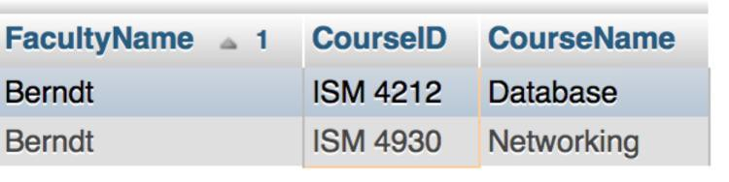

2.
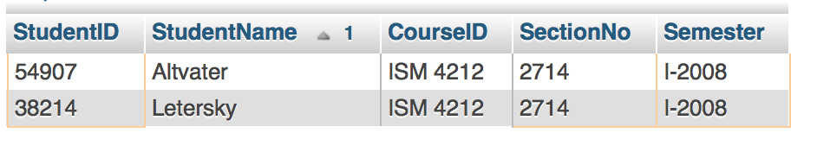

3.
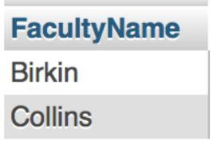

4. From the DDL and Insert files, it looks like Birkin (facultyID 2143) and Collins (4756) are both qualified to teach 3113, and neither of them are qualified to teach 4930. Berndt (facultyID of 3467 is qualified to teach 4930. You may want to add a record in IsQualified that qualified Berndt to teach 3113, and this should test your query to see if it is running correctly.

This is a difficult query. You can try it with a join (easier) or a subquery (more difficult). This query is intended to be a challenge.

5.
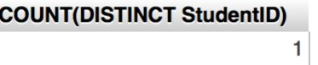

6.
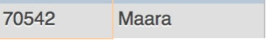

7.
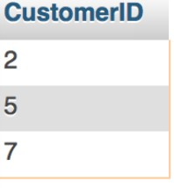

8.
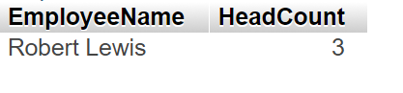

9.
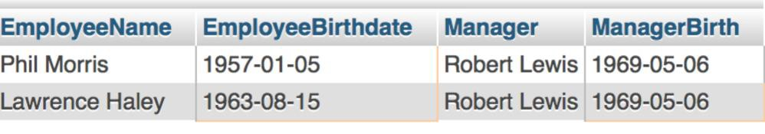

10.
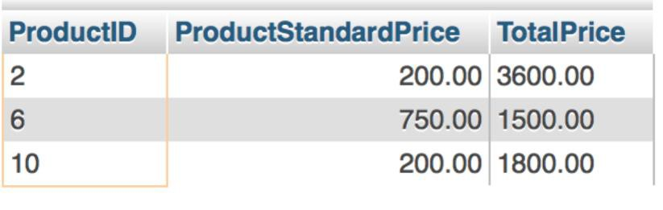

11.
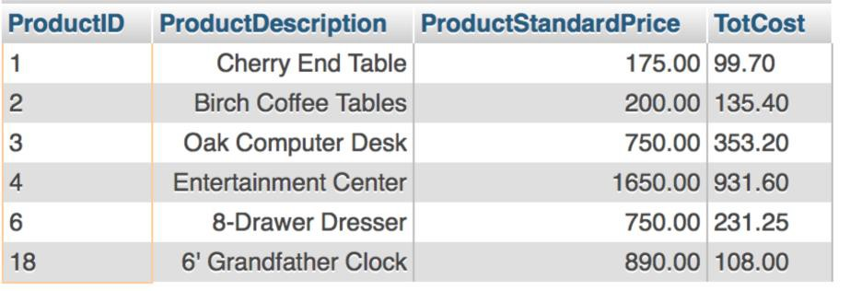

12.
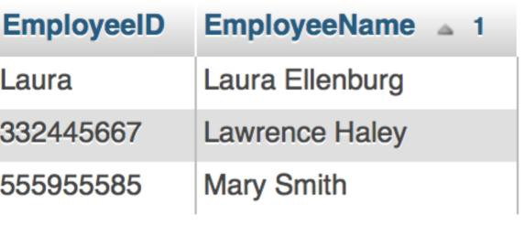

13.
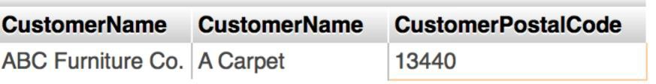

14.
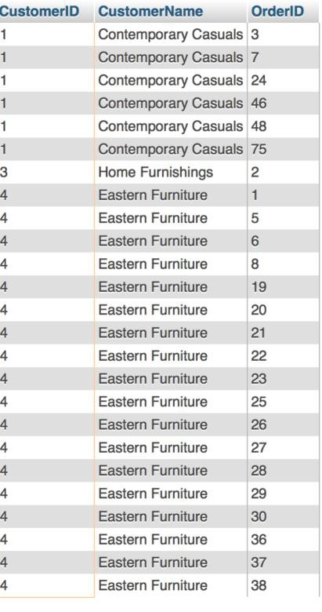

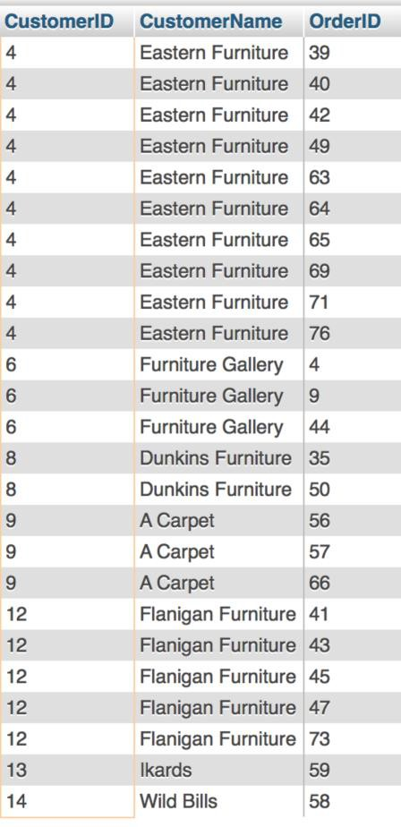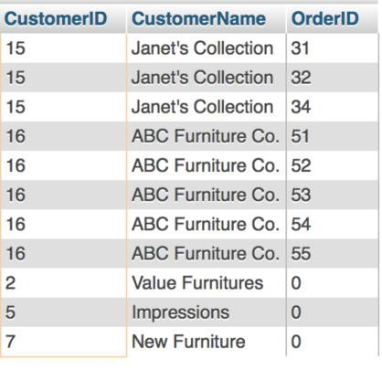

15.
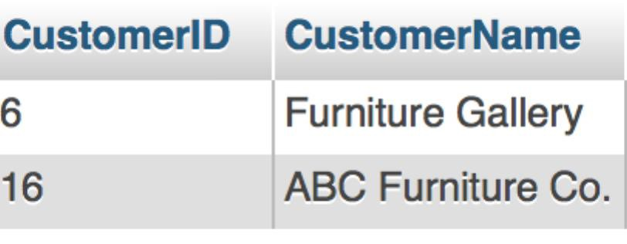

16.

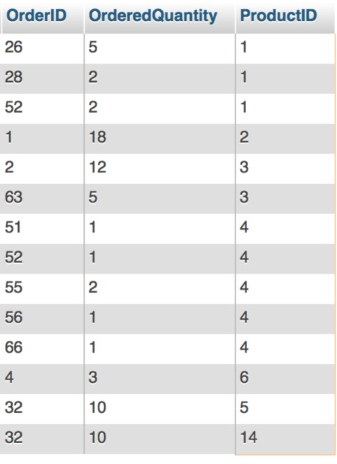

17.
