Instructions to Install XAMPP

Nothing special about the installation. Just go to http://www.apachefriends.org, and download the recommended version for your computer:
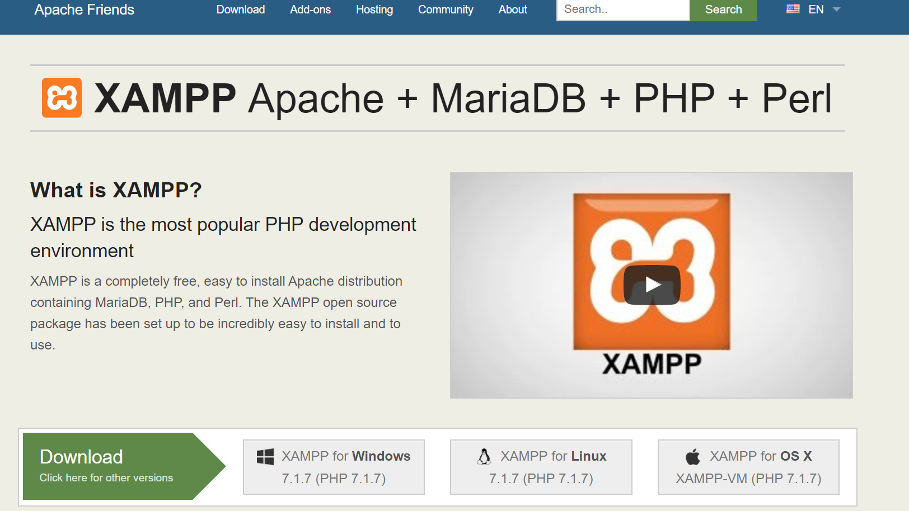
When you first click on the installation file (after downloading), you may get this message:
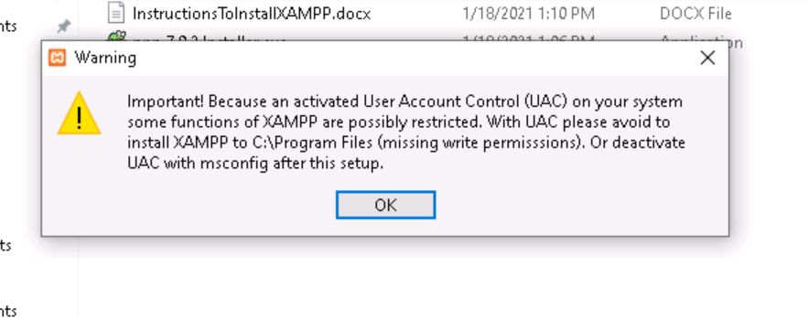
If you do, then it’s an easy fix. See here for one-minute fix.
Here are some detailed instructions.
I placed a shortcut on my taskbar. You can put one on your desktop, or just make sure that you can easily access the program.
To run XAMPP, click the orange-box “X” icon in Windows, or the little gray wheel icon on the Mac.
If you need to know where the program is located:
On Windows: C:\XAMPP\xampp-control.exe
On Mac: /Applications/XAMPP/manager-osx
The first time that you run it, you will see something like the image on the left (in Windows), or similar to the image on the right (Mac).
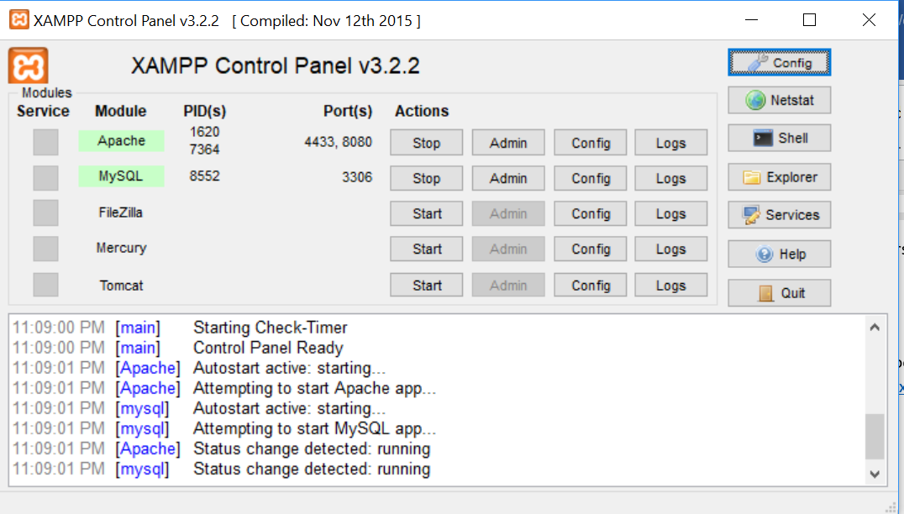 | 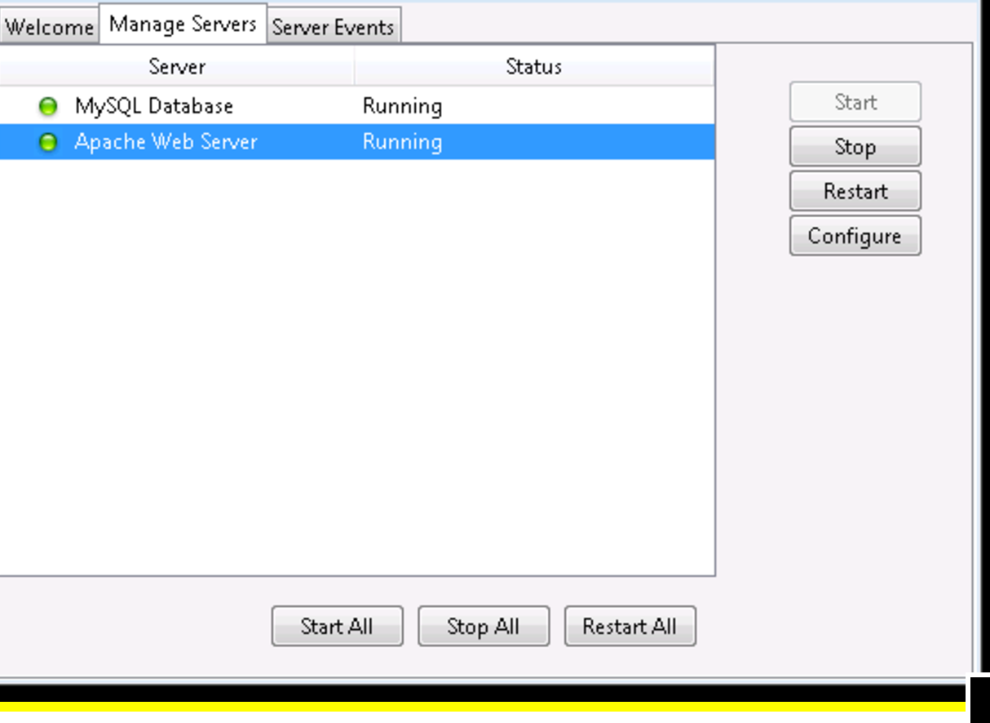
If you don’t have two green boxes or two green lights, you probably have a port conflict. You may find this helpful, and there’s much more if you google your specific issue. Full disclosure: I did not test those configuration solutions on the Mac, since I have never run into those configuration problems with XAMPP on the Mac.
Some Mac Videos: https://www.youtube.com/watch?v=glafmFhd0Ds&vl=en
https://www.youtube.com/watch?v=XmklVBO89MM

​​​​​​

