Possible Configuration Issues when Installing XAMPP
The configuration issues will most likely not apply to Mac users. Mac users may find the following links helpful:
https://www.youtube.com/watch?v=glafmFhd0Ds&vl=en
https://www.youtube.com/watch?v=XmklVBO89MM
Configuration Issues:
You may have a conflict of ports. Open the XAMPP control panel. If it says that ports 80 and 443 are already in use (by Skype, for instance), you can either change the settings on Skype, or on Apache.
- To change your port settings on Apache: Click on the “config” button, Service and Port Settings, and change the ports to something else. I used 8080 and 4433. That worked for me.
- OR, follow these instructions, under “How to Change Apache Default Port in XAMPP.” I tried both, and everything worked. (I didn’t find “Servername Localhost” as instructed in the document. I did find www.example.com:443 and changed that to :4433.
Not sure why, on the FAQs, it states that:
Almost all settings in XAMPP you can change with configuration files. Just open the file in a textedit and change the setting you want. Only FileZilla and Mercury should be configured with the application config tool.
It really worked fine when I changed the Apache ports using the config button on the control panel. Unless they mean something else. Whatever.
Another very good link to help with port conflicts: https://stackoverflow.com/questions/11294812/how-to-change-xampp-apache-server-port
Alternative way to address the issue is to change or delete the applications that are currently using those ports. See: https://premium.wpmudev.org/blog/setting-up-xampp/?ptm=b&utm_expid=3606929-108.O6f5ypXuTg-XPCV9sY1yrw.1&utm_referrer=https%3A%2F%2Fwww.google.com%2F
The above link also addresses configuring PHPMyAdmin for the first time.
Your goal is to run XAMPP and have the Control Panel look something like the image below (with two green buttons, one for Apache and one for SQL):
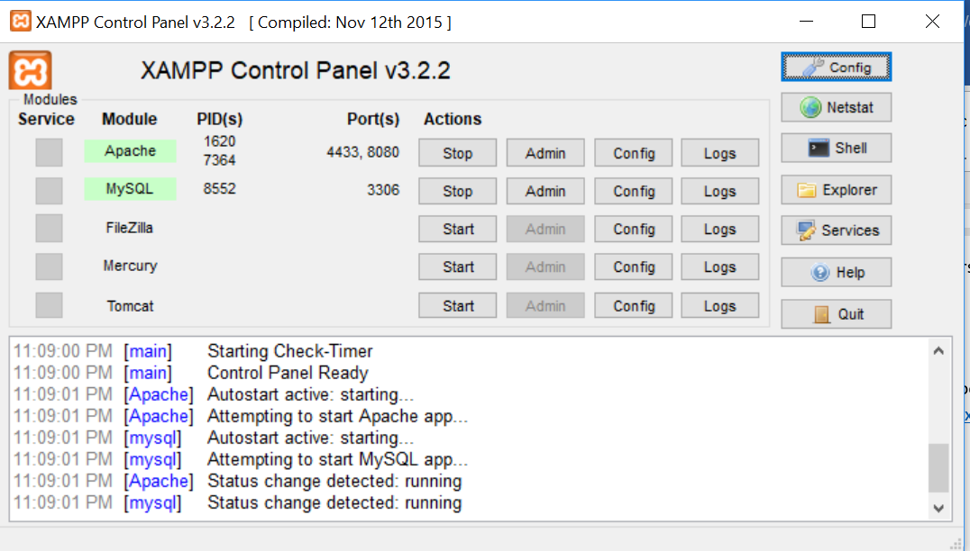 | 