BUSN/CAIS 306
Review Assignment
Information Requirements

This assignment is instead of your team project. We will discuss the requirements and the Excel design together. You may work in teams of two to implement it.
Below is an initial description of the partial requirements. We will add graphing/charting to the projects, and additional functionality may be added, depending upon how many skills we cover. We may add another mini-project when this is complete.
Scenario: You would like to make a major purchase. This could be an item that you want to purchase, or a special trip that you want to go on, or an activity which you would like to pursue. This purchase will cost as much as you can save in approximately 3 months. You are planning to babysit and tutor, as well as put away some of your allowance and any gifts or other money that you may receive. You may be planning other ways to raise funds, and you can add these as well.
Purpose: The purpose of this spreadsheet application is to help you keep track of the money that you are saving, how far you are towards reaching your goal, and how much time you have left to your purchasing deadline. This will help you to decide if you need to save a higher proportion of your earnings or gifts, or if you can save less. Hopefully, this spreadsheet application will help you to plan your savings schedule so that you can make the major purchase by the deadline that you have determined.
Using the application: You will set up your spreadsheet application to make it as easy as possible to enter your data and to interpret the output. You should be able to easily enter the following information:
- Your target amount (how much you want to save: the price of this purchase)
- Your target date (when you need to make this purchase)
- How much you get for each hour of babysitting (can depend on the person for whom you babysit)
- How much you get for each hour of tutoring (can depend on the person you are tutoring)
- Each time you babysit or tutor: enter the date, person and number of hours
- Any regular allowance that you will use towards your savings
- Any gifts or other amounts of money (Chanukah gelt?, birthday gift?, etc.)
You would like to find your progress as easily and clearly as possible:
- How much, in total, have you saved so far?
- How far away are you from your goal at any point in time?
These information items should be very easy to find, on the main (first) worksheet of your spreadsheet.
Excel functionality: The following excel features will be incorporated into this assignment. These are all skills that you covered in 206 or are assumed to know before entering class. Feel free to experiment with additional components
- Data entry
- Data formatting (for different data types)
- Cell formatting (including presentation options, as well as borders and shadings)
- Data replication using a series
- Formulas with relative addressing
- Formulas with absolute addressing
- Use of built-in Excel functions
- Date arithmetic
- Multiple worksheet references
- Renaming worksheets
- Setting up and using a vlookup table
- Charting/graphing
- Using the IF function
Make it yours: You are not limited to babysitting, tutoring and gifts. You may add other categories, as long as you use similar Excel skills. You will also customize the look of the spreadsheet, by using appropriate and creative formatting, including differentiating your headers and totals, using borders, and color (in a limited and appropriate way). You may add a picture that is related to your purchase.
On the following pages, you will see some screen shots of suggested pages.

Here is a screen shot of what the front page should look like:
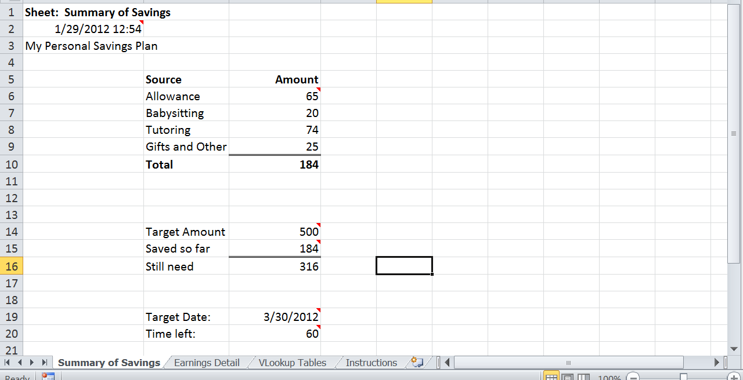

Here is screen shot of the Earnings Detail:

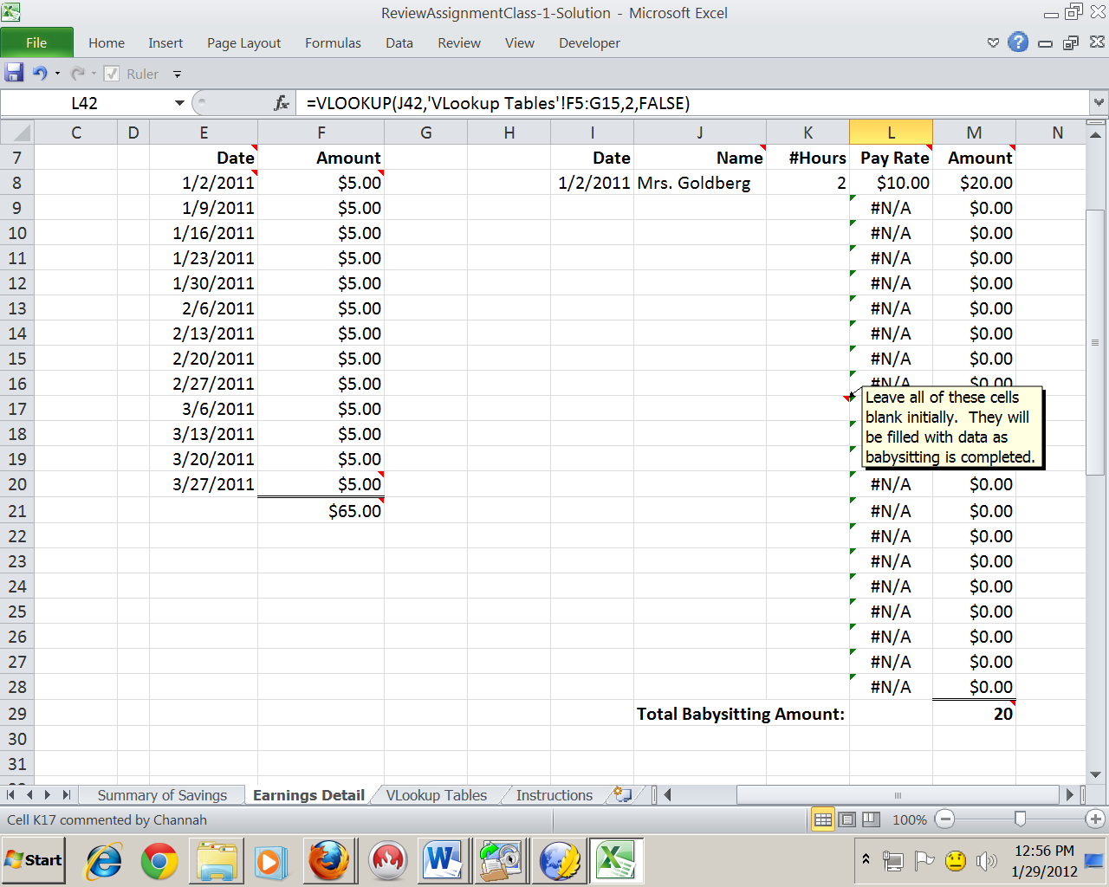

Here is a screen shot of the lookup tables:

If you need more help: on the following pages are screen shots of the same pages, with comments:

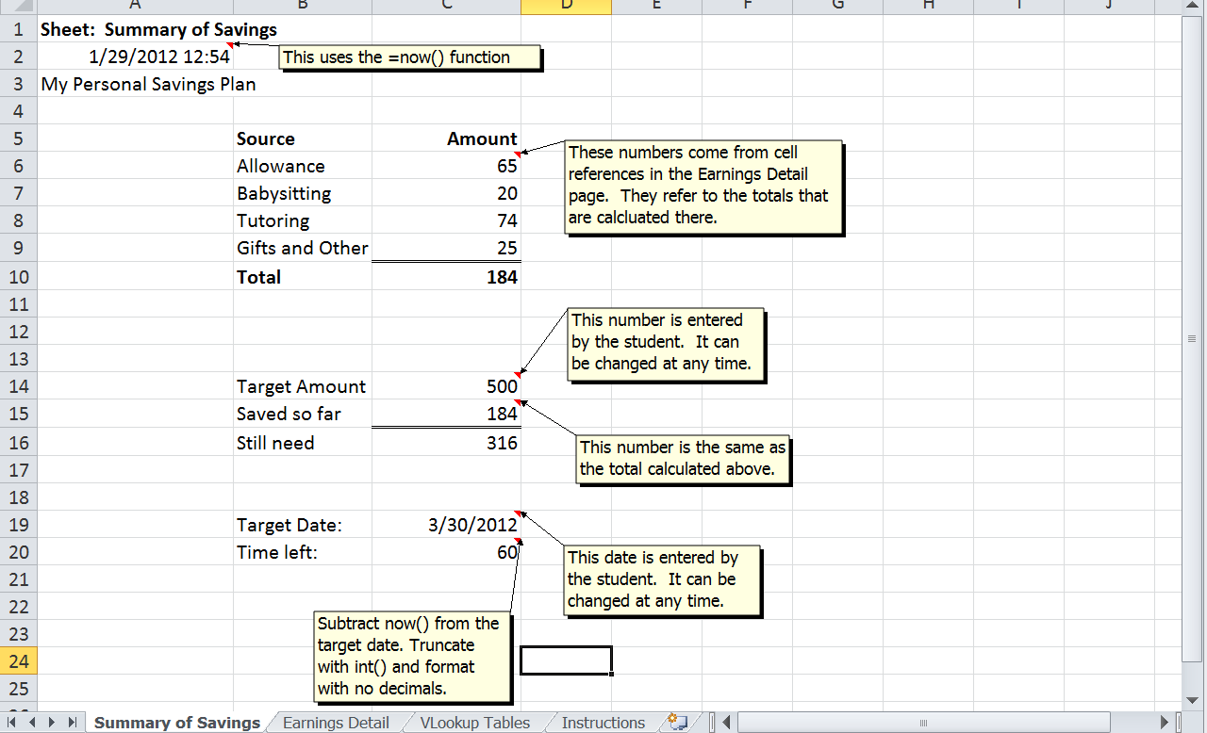

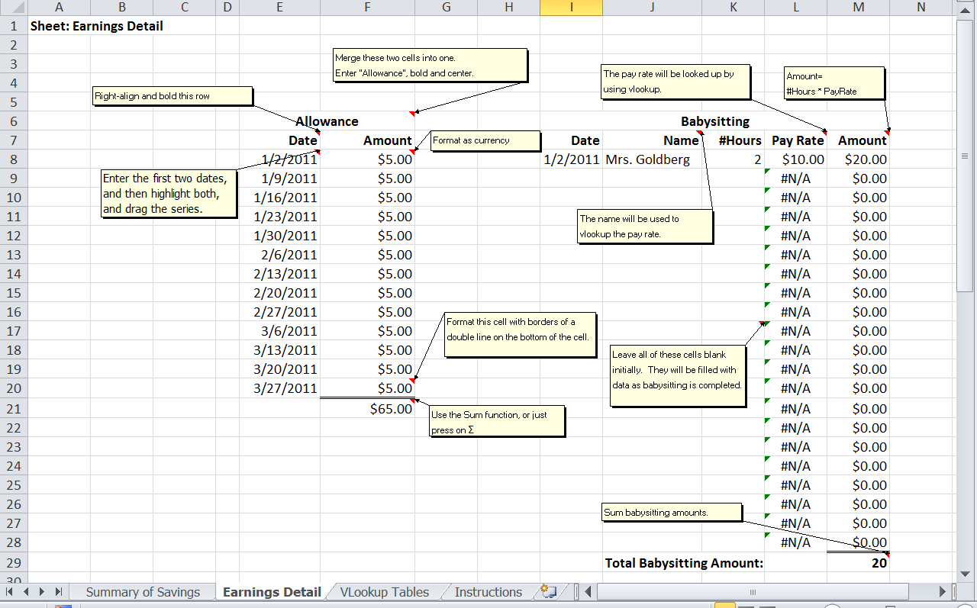
If you are still stuck, you may download the solution, which has detailed instructions on the tab labeled “Instructions”.

