http://chandoo.org/wp/2010/06/17/compare-2-lists-in-excel/ (updated for 2019)

Become a Comparison Ninja – Compare 2 Lists in Excel and Highlight Matches
Originally posted on June 17th, 2010 in Excel Howtos , Featured , Learn Excel - 43 comments
Comparison of lists of data is something that we do all the time. Today, lets learn a few tricks that you can apply immediately to compare 2 lists using Excel.
We will learn how to compare 2 lists of data in 3 + 1 different ways. (click on links to jump to that section of post)
- Highlight items that are only in first list
- Highlight items that are only in second list
- Highlight items that are in both lists
- Search and highlight matches in both lists - Home Work

Understanding the Comparison Logic:
Whenever you compare 2 sets of values, there are 3 possibilities, as shown in the illustration below:
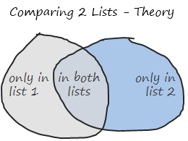
Apart from looking like imperfect circles that Mike Alexander would draw, these circles show important concepts of set theory in simplest form.
[there is a fourth possibility of a value not being in either lists, we omit that for now]

What you need to compare 2 lists?
1. Of course, you need 2 lists of data. But, just to make formulas simpler and easier to read, lets name the 2 lists as lst1 and lst2.
Let’s assume your data looks like this:
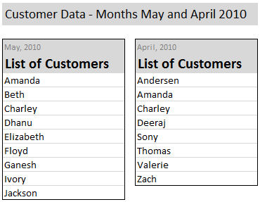
2. Also, you should know how to use COUNTIF Excel Formula, it is so awesome, I wonder why MS hasnt called it MAGIC() ?
So in order to find-out if a value is in list 1 only, we use a formula like =COUNTIF(lst2,value)=0.
This checks whether “value” occurs anywhere in lst2 and returns false if that is the case. (it assumes that value is already in lst1).
Highlighting Items that are in First List Only
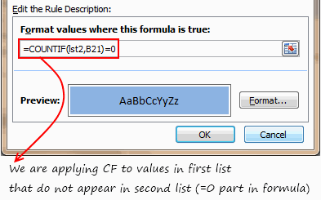
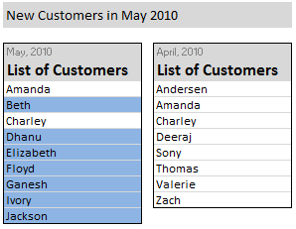
- Select values in first list (assuming the values are in B21:B29)
- Go to conditional formatting > add rule (related: conditional formatting basics)
- Select the rule type as “formula”
- Write a rule like this: =COUNTIF(lst2, B21)=0
- Double check the reference and make sure it is relative (and not like $B$21). Select the reference and press F4 repeatedly to change it to relative reference
- Set the formatting you want.
- Click ok.
- All done. You should see values only in first list highlighted.

Highlighting Items that are in Second List Only
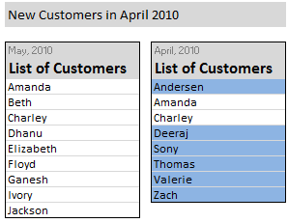
- Select values in second list (assuming the values are in C21:C28)
- Go to conditional formatting > add rule (related: conditional formatting basics)
- Select the rule type as “formula”
- Write a rule like this: =COUNTIF(lst1, C21)=0
- Repeat steps 5-8 as above.

Highlighting Values in Both Lists:
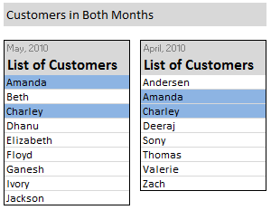
Now, it gets interesting as you should apply conditional formatting individually to both lists.
- Select values in first list (assuming the values are in B21:B29)
- Set the conditional formatting rule as =COUNTIF(lst2,B21)>0
- Apply formatting as you want.
- Now select second list (assuming the values are in C21:C28)
- Set the conditional formatting rule as =COUNTIF(lst1,C21)>0
- Again, apply formatting as you want.
- That is all.

Searching for a value and Highlighting Matched Items in Both Lists – Your Homework:
This is another common thing we do. We want to find-out a given value (say in A1) is in the both lists, first list or second list and highlight all the matches. Like this:
Of course, doing this is very straightforward in Excel once you understand the above 3 things. So I am leaving this as your home work.
Go ahead, figure this out, practice it on a workbook. When you are satisfied with your result, post the answers here. Discuss!

Download Example Workbook on Comparing 2 Lists in Excel:
Go ahead and download the example workbook on comparing 2 lists in excel. [download from mirror]
It also contains the answer to homework above. Play with it and become comparison ninja.

